
Student Name | Pradeep Saran
Email ID | pradeepsaran535@gmail.com
Project Title | Customer Support Case Management
Salesforce Cloud | Service Cloud
Role Focus | Salesforce Business Analyst

1. PROJECT OVERVIEW & PROBLEM STATEMENT

AS-IS Problem: Customer support requests are currently managed manually through emails, phone calls, and Excel sheets. There is no centralized system to track complaints, causing delayed responses, inconsistent follow-ups, and poor visibility into case status. Support agents lack a structured workflow and management has no real-time service-performance insight.

2. BUSINESS ISSUES & BUSINESS IMPACT
Business Issues
Complaints received via email & phone.
Cases manually tracked in spreadsheets.
No SLA tracking or escalation process.
Customers repeatedly follow up for
status.
No visibility into open or overdue cases.
Business Impact
Delayed case resolution.
Poor customer experience & satisfaction.
Increased support-agent workload.
No management performance metrics.
Risk of SLA breaches and compliance
issues.

3. BUSINESS OBJECTIVES & PROJECT SCOPE
TO-BE Objective: Implement Salesforce Service Cloud to standardize and automate customer support operations, capturing all customer complaints in a single system, automating routing, monitoring SLAs, and providing real-time dashboards.
IN SCOPE OUT OF SCOPE
Case Creation: Email-to-Case & Web-to- Telephony (CTI) Integration.
Case. Chatbot or AI-based automated support.
Case Assignment & Escalation Rules. ERP or billing system integration.
SLA tracking using Entitlements & Milestones.
Reports and Management Dashboards.

4. AS-IS VS TO-BE COMPARISON
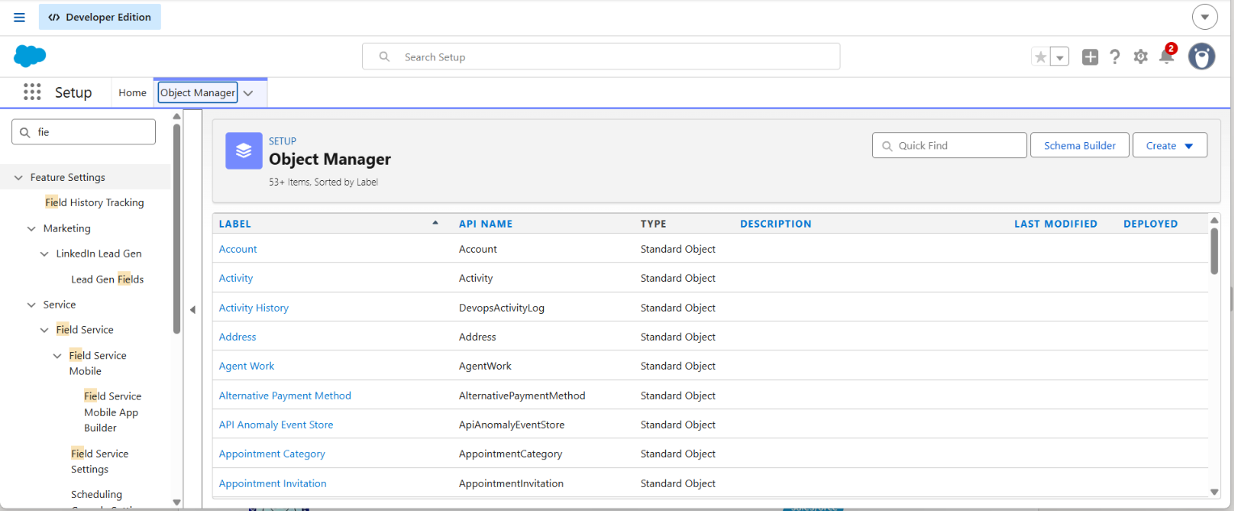
Area | AS-IS (Current State) 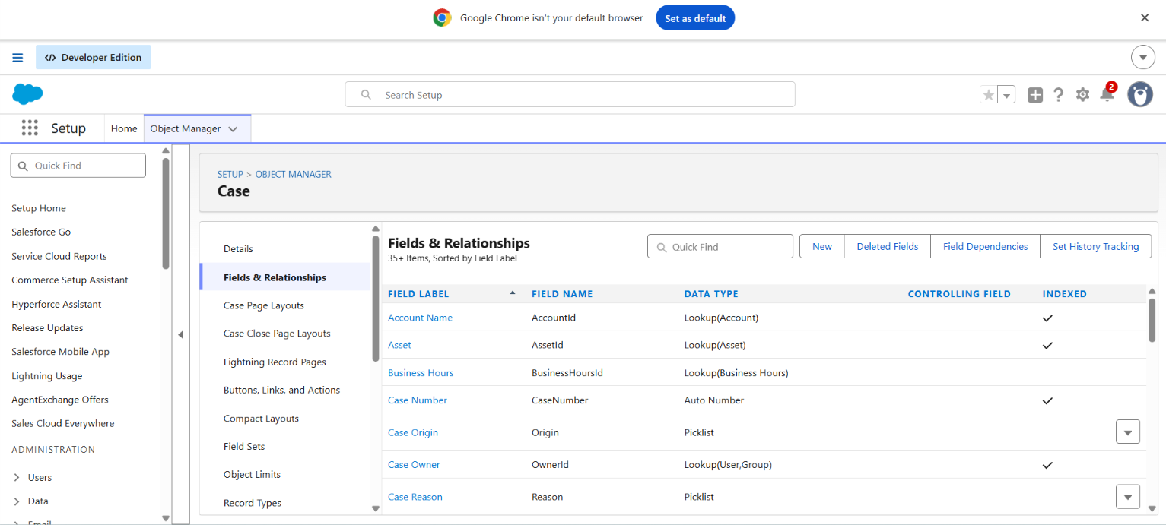 | TO-BE (Salesforce Target)
Case Tracking | Excel & Emails | Salesforce Cases (Centralized)
Assignment | Manual Distribution | Automated Assignment Rules
SLA Tracking | Not Available | Salesforce Entitlements & Milestones
Customer Updates | Manual Follow-ups | Automated Email Notifications
Reporting | None / Manual Static Files | Real-time Dashboards & Reports
5. SALESFORCE DATA MODEL & OBJECT MANAGER SETUP

6. CASE CREATION CHANNELS - WEB-TO-CASE CONFIGURATION
Web-to-Case allows customers to submit support issues directly from a web form, automatically generating Case records in Salesforce with default values and origin tracking.
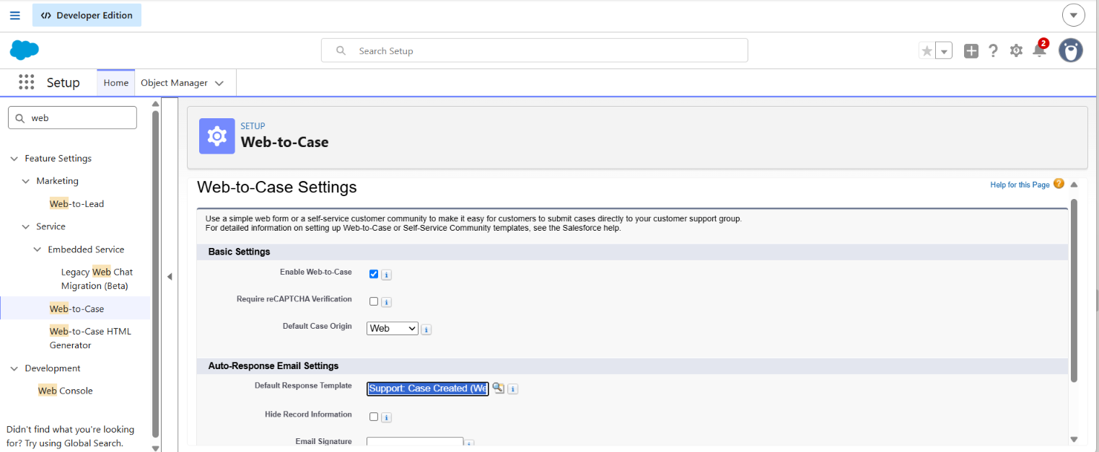

7. CASE CREATION INTERFACE & FIELD MAPPING

The standard Case creation dialog configured for support agents, defining required business fields such as Status, Priority, Case Origin, Account Name, and Contact details.
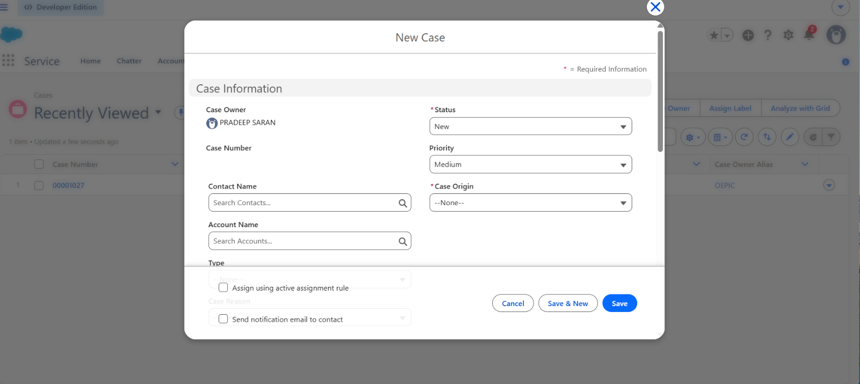

8. EMAIL-TO-CASE AUTOMATION & ALL OPEN CASES VIEW
Incoming customer support emails (including Gmail forwarding confirmation tests) are automatically converted into Case records and displayed in the 'All Open Cases' list view.
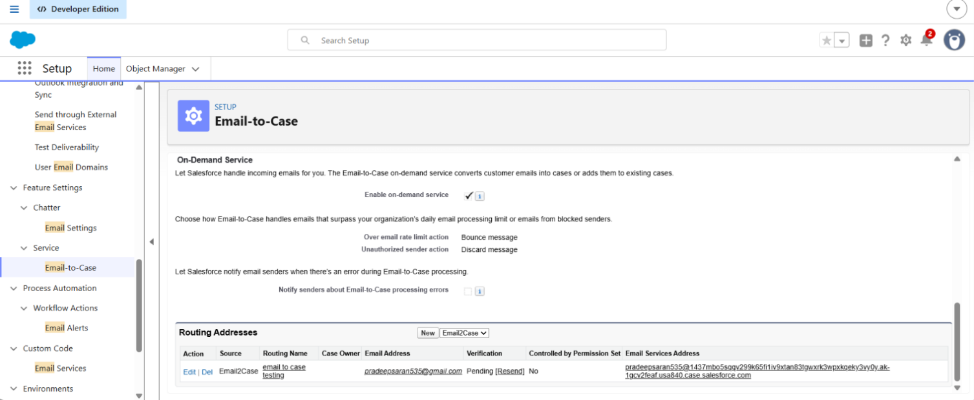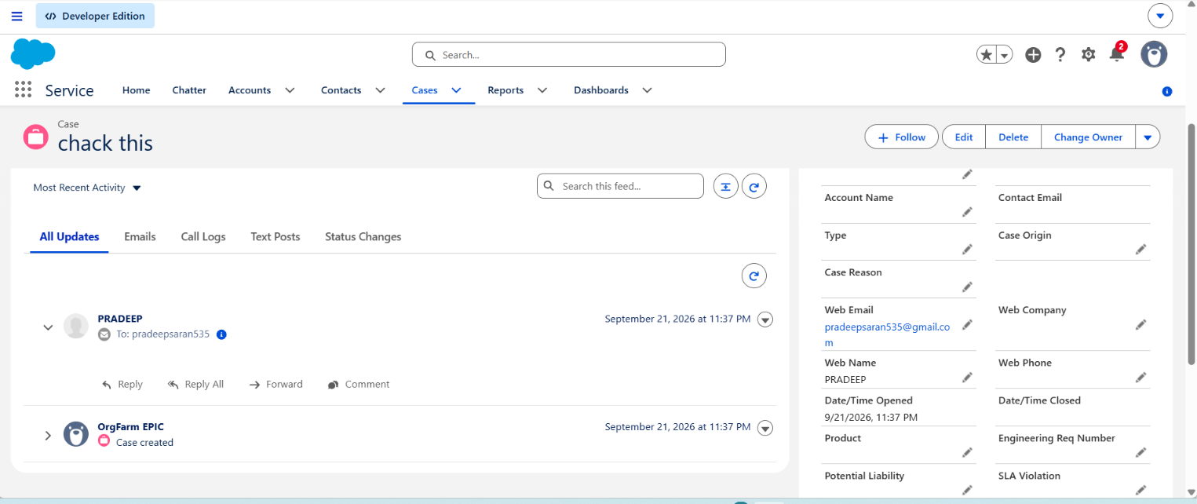

9. CASE ASSIGNMENT RULES EXECUTION

Automated routing logic directs incoming cases to specific agents or queues based on predefined criteria such as Case Type and Priority.
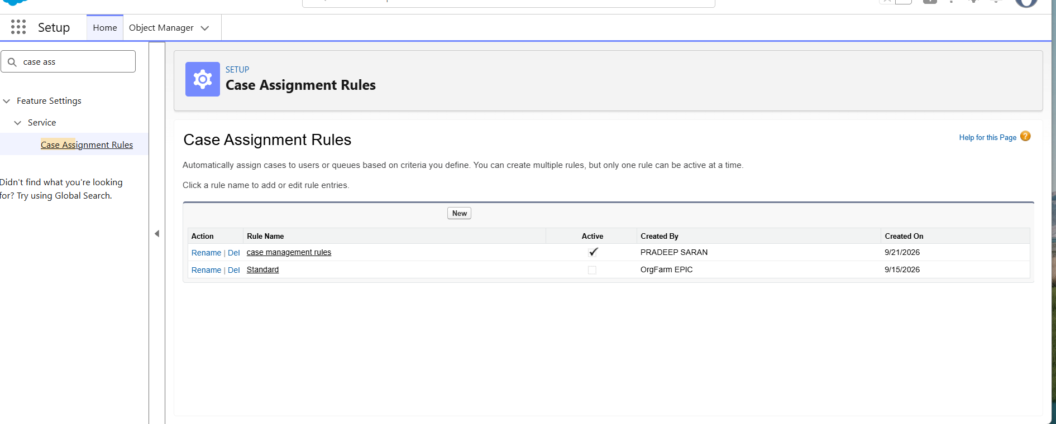

10. REAL-TIME SERVICE PERFORMANCE DASHBOARD
Management reporting dashboard providing real-time visibility into case volume, case origins (Phone, Web, Email), and individual agent workload metrics.
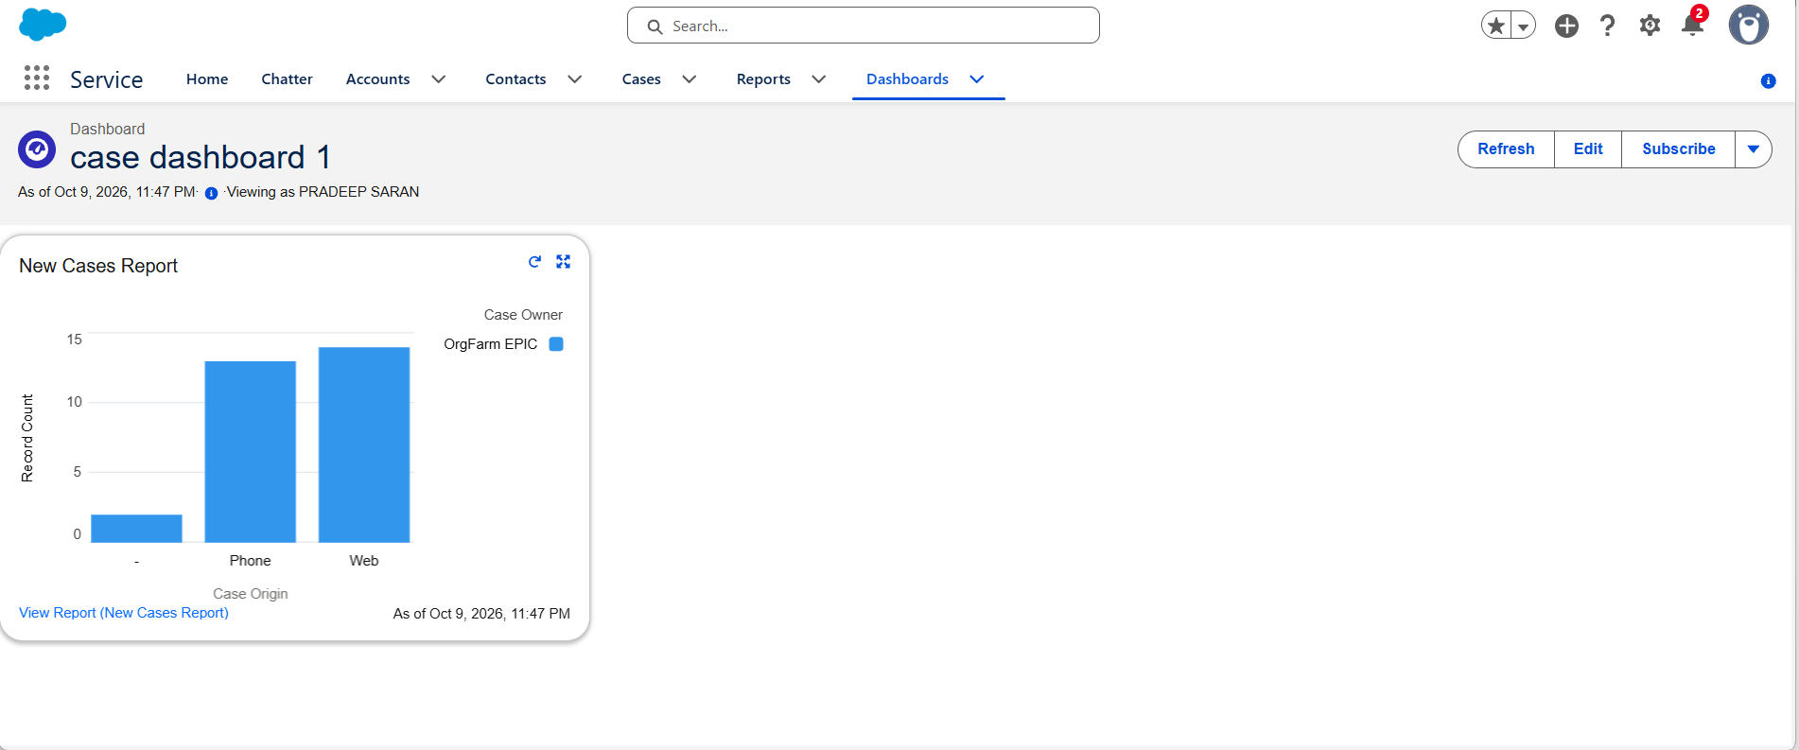

11. BUSINESS ANALYST DELIVERABLES SUMMARY

Milestone / Area | BA Deliverable Document | Core Objective / Value Delivered
Service Cloud  Foundation | Process Understanding  Document | Mapped AS-IS processes to Service Cloud capabilities.
Case Data  Requirements | Field Requirement Document | Defined picklists, mandatory fields & validation rules.
Case Intake  Channels | Case Creation Flow Diagram | Designed Email-to-Case and Web-to-Case routing flows.
Process Automation | Case Assignment Rules  Document | Established automated routing logic based on case priority.
Overall Solution  Design | Client Requirement & Design  Pattern | Complete alignment between business needs & Salesforce setup.

